Grow the Future

A Practical Guide for Developing Sector Action Plans for Finding and Keeping Workers in Agriculture & Food Processing in Ontario

A Practical Guide for Developing Sector Action Plans for Finding and Keeping Workers in Agriculture & Food Processing in Ontario

A Practical Guide for Developing Sector Action Plans for Finding and Keeping Workers in Agriculture & Food Processing in Ontario

A Practical Guide for Developing Sector Action Plans for Finding and Keeping Workers in Agriculture & Food Processing in Ontario

Prepared by:
Canadian Agricultural Human Resource Council (CAHRC)

With the assistance of:
Perennial Talent Inc.

September 2021
The views in this document do not necessarily reflect the opinions of the Federal or Provincial governments.

This project was funded by the Canadian Agricultural Partnership a five-year federal-provincial-territorial initiative.

Table of Contents
Introduction 3
Background 3
Overview of a Sector Action Plan 3
Who is this Guide for? 4
What can this Guide be Used for? 5
How to Use this Guide 6
Step 1: Identify Relevant Workforce Issues 6
1. Create a vision statement 6
2. Collect and review information on the sector 7
3. Consult the Workforce Issues and Actions Reference Table 8
Step 2: Identify a List of Proposed Actions 8
1. Consult the Workforce Issues and Actions Reference Table 8
2. Review existing sector action plans 9
Step 3: Tailor Workforce Issues and Actions to the Sector 10
1. Consult sector stakeholders 10
Step 4: Create the Plan 13
1. Create objectives 13
2. Identify needed partners and timeframes 15
3. Estimate cost 16
4. Identify a plan for evaluation 16
5. Review your Sector Action Plan 18
Tools and Templates 19
Create a Vision Statement Template 19
Workforce Issues and Actions Tracking Tool 21
Workforce Issues and Actions Reference Table 24
Sample Consultation Questions 35
Sample Evaluation Measures 37
Sector Action Plan Template 38
Sample Sector Action Plan 41
Sector Action Plan Checklist 42

Introduction

Background
The agriculture sector is the economic engine of Ontario, supporting 97,800 jobs in primary agriculture including 28,800 temporary foreign workers, and over 101,000 jobs in food and beverage processing in 2018. In past weeks, the COVID-19 crisis has accentuated labour shortages in the sector. Many agriculture and food processing employers consider labour shortages as their top issue as they deal with the fallout from the current crisis.

The goal of the two-year project is to assist Ontario’s agriculture and food processing industry in addressing increasing labour shortages while preparing Ontarians with the future skills needed to work in the sector. Information about labour markets are described in many ways and can be confusing to job seekers and employers. The project has developed a common framework for describing the agricultural and food processing labour market so that job seekers and employers can understand where the jobs are in the sector. The project has also developed and piloted templates for industry associations to use to develop their own subsector workforce action plans. With these action plans, Ontario’s agriculture and food processing sector will be able to assist employers to find and keep workers and help their workforce to adapt to emerging skills that will be needed in the coming decade. Ultimately, these workforce action plans will help the agriculture and food processing industry secure a highly skilled workforce to grow the industry in future years.

Ontario’s bright production outlook for agriculture is dependent on ensuring there are enough workers to fulfill the sector’s growth potential. This project will assist the industry in assessing current needs, then develop programs and training opportunities to prepare the workforce of the future for an exciting and satisfying career in agriculture while filling the labour gap.

Overview of a Sector Action Plan
A sector action plan is a tool that can be used to assist employers to find and keep workers and help their workforce to adapt to emerging skills that will be needed in the coming decade. This type of plan includes several elements, including a vision, strategic goals, objectives, and the actions. Strategic goals can be grouped into five overarching themes with SMART (specific, measurable, achievable, relevant, and timely) objectives and actions needed to achieve these objectives and address the specific pain points that the sector is facing. This guide will walk you through how to define each of the elements below.

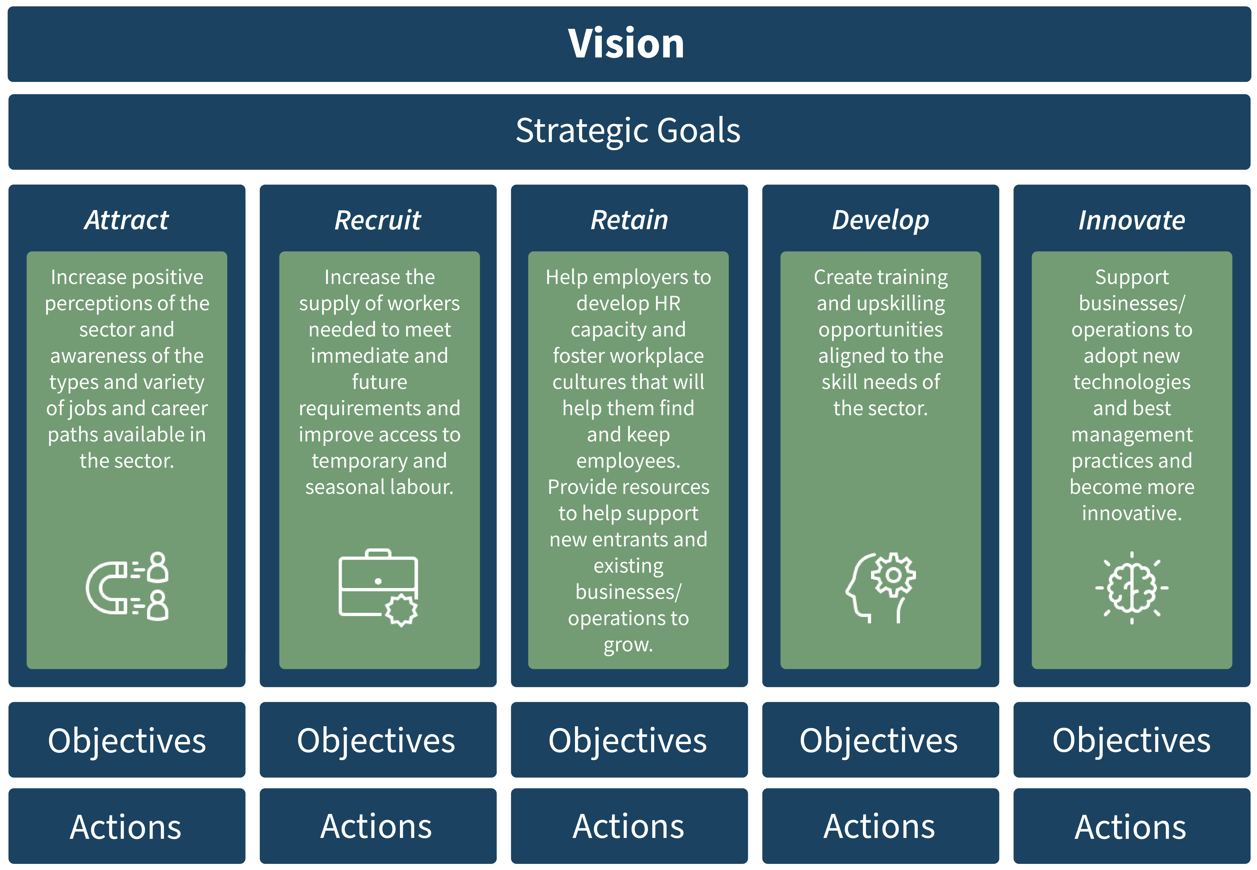

Who is this Guide for?
The intended audience of this guide is agriculture and food processing industry associations in Ontario.

What can this Guide be used for?
One purpose of this guide is to help industry associations develop their own sector action plans to assist employers to find and keep workers and help their workforce to adapt to emerging skills that will be needed in the coming decade. Step 1 of this guide includes tools and templates to help you identify the workforce issues your sector is facing. Step 2 includes tools and templates to help you identify proposed actions for the different workforce issues. Step 3 includes tools and templates to help you identify priority action items and tailor the proposed actions to your sector’s unique needs. This section also includes information on how to identify, consult, and engage relevant stakeholders to help prioritize the proposed actions. Step 4 includes tools and templates to guide the creation and implementation of a sector action plan, including creating SMART objectives, identifying partner organizations, estimating overall cost, planning for how to evaluate success, and reviewing the overall plan. At the end of this guide, you will find a comprehensive reference table of common workforce issues, proposed actions, and examples of solutions that can be used as a starting point for developing your sector specific plan.

A second purpose of this guide is to help industry associations collect and organize relevant information to apply for funding for their project(s). One source of funding is the Ontario Labour Market Partnerships (OLMP) program. The OLMP program provides funding to local communities, sector groups, and employer associations to support the development and implementation of strategies in the areas of local economic development, labour force adjustments, and human resource planning.

Through the OLMP program, there is funding available for projects that answer three types of questions:
- What is the labour market issue, and who is affected by the issue?
- What are the solutions to the labour market issues identified, and what is the desired outcome?
- How can the identified solutions be implemented, and what will be the duration and cost of the implementation?
The steps in this guide cover all three of these questions. As such, some funding applications may focus on only one of the steps, whereas others may include all four steps. You can find more information about the OLMP program by visiting this link.

How to Use this Guide
This guide is meant to be used as a starting point for developing a sector action plan. It contains a list of potential workforce issues and proposed actions that may not be applicable to every sector. The goal is for industry associations to work through this guide and select those issues and proposed actions that are most applicable to their sector, and then tailor these issues and proposed actions to meet their specific needs.

This guide helps you to create your sector action plan by guiding you through the following four steps:

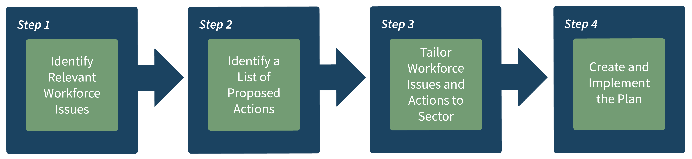

Step 1: Identify Relevant Workforce Issues

Purpose: The tools and templates provided in this section will help you to answer the question:
☐ What are the workforce issues that your sector is facing?

Create a vision statement
An important first step is the creation of a vision statement which can help to frame and guide the development of the overall sector action plan. A vision statement answers the question, why this sector action plan is needed and describes the end goal for creating the plan. It can help to frame the central issue guiding the need for the plan. The vision statement also acts as a starting point for inspiring action.
When developing a vision statement with the project team, ensure that the vision statement is:
- Short and easy to understand. This will help make it easy to follow and remember.
- Future oriented. The focus should be on what you hope to achieve and by when.
- Engaging. The statement should help to inspire the various stakeholders to do their part to achieve the goal.
- Actionable. The statement should include verbs that call or encourage others to action.
Sample Vision Statement:
“By 2025, the agriculture horticulture and landscape horticulture industry will effectively recruit, retain, and grow a diverse workforce to produce premium BC-grown products and quality service.”
Use the “Create a Visions Statement Template” to develop a vision for your sector action plan.

Collect and review information on the sector
To gain an understanding of the issues facing your sector, collect and review sector specific research and reports. For example, Labour Market Information (LMI) reports describe the current and future labour market challenges and trends affecting a sector. These types of reports also provide insight into the types of recruitment and retention challenges agriculture and food processing face. Other sector surveys and research reports can also provide additional insights into the types of issues the sector is facing. CAHRC recently released a report describing labour productivity challenges, broken down by subsector (i.e., supply managed, field crops, red meat, horticulture, food processing, sales and service), which could be used as a good starting point for identifying labour productivity challenges within your subsector. Use the “Workforce Issues and Actions Tracking Tool” to track the issues you have identified.

Consult the Workforce Issues and Actions Reference Table
The “Workforce Issues and Actions Reference Table” summarizes recruitment and retention research from across Canada and across agriculture and food processing. Review the issues column and complete Part 1 of the “Workforce Issues and Actions Tracking Tool” “Workforce Issues and Actions Tracking Tool” to add and remove workforce issues that may be relevant to your own sector.

Outcome: By the end of this step, you will have developed a vision statement and identified a starting list of workforce issues relevant to your sector.
Completed Tools and Templates: Create a Vision Statement Template and Workforce Issues and Actions Tracking Tool (Part 1).

Step 2: Identify a List of Proposed Actions

Purpose: The tools and templates provided in this section will help you to answer the question:
☐ What are the proposed actions to the labour market issues identified?

Consult the Workforce Issues and Actions Reference Table
After you have identified a list of potential workforce issues relevant to your sector, use the “Workforce Issues and Actions Reference Table” to map a list of proposed actions or solutions to these issues.

This list of proposed actions was developed through consultation with sector stakeholders and by summarizing research and existing sector action plans. Please note that this list is not an exhaustive list and that not all the issues and proposed actions may be relevant to your sector. Use the “Workforce Issues and Actions Tracking Tool” and complete Part 2 to list proposed actions mapped to the workforce issues that you identified in Part 1.

Sample Mapping
For example, if your sector is finding it difficult to find and keep workers because potential workers are not aware of the various career options, a possible solution may be to create an online career portal or job resource centre.

Review existing sector action plans
You may also want to review the Canadian Agriculture and Agri-Food Workplace Action Plan, that outlines a series of strategies for addressing the current and the future skills and human resource supply required by the Canadian agriculture and food processing sector and the labour shortfalls it faces. Food and Beverage Canada (FBC-ABC) is also leading a National Workforce Strategy to address the food and beverage manufacturing labour challenges. In partnership with FBC-ABC, Food and Beverage Ontario (FBO) has also developed a strategy outlining priorities for supporting Ontario’s food and beverage manufacturing sector. These existing sector action plans can help you to identify which solutions are already in development.
Outcome: By the end of this step, you will have identified a starting list of proposed actions mapped to your sector’s specific workforce issues.

Completed Tools and Templates: Workforce Issues and Actions Tracking Tool (Part 2).

Step 3: Tailor Workforce Issues and Actions to the Sector

Purpose: The tools and templates provided in this section will help you to answer the questions:
☐ Who is affected by the identified workforce issue? (region, community, industry, job seeker group, etc.)
☐ What workforce issues and proposed actions should be treated as priorities?

Consult sector stakeholders
After you have a list of workforce issues and proposed actions, you will need to tailor them to fit the needs of your specific sector. Consultation with sector stakeholders will allow you to develop a more tailored and prioritized list of issues and proposed actions and at the same time help to build sector interest and engagement.

Identifying stakeholders:
Sector stakeholders may include industry associations and sector councils, employers, employees, training and educational institutions and partners, Government, and community leaders. To identify stakeholders, think about:
- Who is affected by the labour market issue? (e.g., region, community, industry, job seeker group, etc.)
- Who will be affected by any of the proposed solutions?
- Who has vested interest in the success of this workforce action plan?

Choosing a consultation method:
There are a few different consultation methods you can use to gain an understanding of the sector issues and determine which solutions would help.

Each of these consultation methods have pros and cons.

Method | Pros | Cons | When should it be used?
Interviews | - In-depth information  - Allows for clarification  - Tailor probes and discussion to the individual | - Time-consuming  - More costly | - When it’s challenging to get stakeholders together for a focus group  - When you are looking to get in-depth detailed information
Focus Groups | - Encourages discussion and brainstorming  - Group members can build off of each other’s ideas  - Generates new ideas  - Confirms information gathered through other means  - Gathers information from a group of people at one time | - Some group members may dominate the discussion  - Can take longer to summarize the results | - When you want to brainstorm ideas to complex issues  - When you are looking to get consensus around an issue or proposed action
Surveys | - Reaches many stakeholders at once  - Easy to administer  - Allows you to gather insights broken down by certain factors (e.g., region, size of business) | - Difficult to ask follow-up questions or open-ended questions  - People experience survey fatigue | - When you already have a good sense of the issues and proposed actions  - When you would like to confirm with a broader sample of stakeholders

The “Sample Consultation Questions” provides a list of questions that can be used to guide consultation with stakeholders using one of the above methods.

Identifying priorities:
During consultation, you can ask stakeholders to identify which of the workforce issues and proposed actions from the starting list are critical and should be treated as priorities. This will help you to focus your time and resources on the most critical issues facing the sector. It is important to keep the list of proposed actions to a manageable number as it is not possible to address all issues at once.

The “Workforce Issues and Actions Reference Table” contains a list of similar programs that may be relevant to your proposed action. It may be helpful to speak to these program owners to gather information on what worked, what did not work across these programs or even explore potential partnership opportunities. You can also gather information on timeframes and cost, which will help you to estimate timeframes and costs for your own proposed actions. This will help you to refine your proposed action and apply any lessons learned.

Use the “Workforce Issues and Actions Tracking Tool” and complete Part 3 to track critical workforce issues and proposed actions.

Once you have identified which workforce issues are critical and which proposed actions should be treated as priorities, you can complete Part 1 of the “Sector Action Plan Template”.

Outcome: By the end of this step, you will have narrowed the list of workforce issues to those most relevant and critical to your sector. You will also have identified which issues and proposed actions should be treated as priorities.

Completed Tools and Templates: Workforce Issues and Actions Tracking Tool (Part 3) and Sector Action Plan Template (Part 1)

Step 4: Create the Plan

Purpose: The tools and templates provided in this section will help you to answer the questions:
☐ How can the identified proposed actions be implemented?
  - How do you intend to address the workforce issue and what is your desired outcome (i.e., partners, activities, and expected results)?
  - How long will it take to address the identified workforce issue (i.e., duration, anticipated start)?
  - Do you have an estimate of what it would cost to address the workforce issue (i.e., estimated project costs)?

Create objectives
The next step in creating your sector action plan is to take the critical and priority issues that you have identified in Step 3 and translate them into SMART objectives. Objectives describe what will be accomplished because of your actions. These objectives allow you to quantify what success looks like.

Objectives should be SMART:

Specific | Objectives should be clearly defined and understood. Objectives should address the who, what, where, when, and why. Vague objectives are unhelpful because they do not provide enough direction for the workforce action plan. You want to take the time to specifically define your desired end state. | What do you want to accomplish?  Who will you need to involve in the proposed solution?  When do you want to do this?
Measurable | The outcomes can be observed, tracked, or measured. By making it measurable you can track progress and determine how far you are from reaching your objective. | How will you measure progress and know you have met the objective?
Achievable | The objectives should be challenging but attainable and at the same time practical. Setting unrealistic goals could lead to sector stakeholders becoming frustrated with the lack of progress. | Are the project resources in place to achieve the objective?
Relevant | The goals should align with the broader strategic goals and vision for the workforce action plan. | How does this project relate to the overall strategic goals and vision?  Why is this action plan needed now?
Timely | There should be a timeline or deadline in place for achieving the objective. Adding a deadline ensures a sense of urgency to completing the action item. | What is the deadline for achieving this objective?
Sample SMART Objective:

Issue | SMART Objective
Young people and new entrants do not see agriculture and food processing as a good career choice. | By 2023, at least 30% of employees and new entrants surveyed, report a willingness to pursue a career in the sector.
Lack of education in schools about food, food production, farming, food processing, and career options. | Develop a certificate program on … by the year 2022 with an initial enrollment rate of 50 students per year.
Limited supply of domestic labour. | By 2022, report an increase of 5% in domestic workers working in the sector when compared to the previous year.

Complete Part 2 of the “Sector Action Plan Template” to create objectives mapped to each issue you have identified as critical and as a priority. Please note that one objective can be mapped to more than one issue and proposed action.

Identify needed partners and timeframes
For each proposed action you identified in the “Sector Action Plan Template”, you will need to fill in the “Partners” column and identify who will need to be involved to ensure the proposed action is successful. For example, if the proposed action focuses on developing a new training program, you will likely need to involve an educational or training partner.

You will also need to identify a proposed time frame for each proposed action that you have identified. When do you expect to be able to start the proposed action and what is the expected duration? Complete Part 3 of the “Sector Action Plan Template” to identify partners and add timeframes for each proposed action.

Estimate cost
At this step you can begin to estimate what it would cost to address the identified workforce issue using the proposed action. When determining costs, consider what resources you will need (people and things) and the anticipated timeframe. For example, if developing a skills training course, you will need to determine the cost to develop and deliver the content and even the cost per participant.
Sources of Funding for Sector Action Plans:
Ontario Labour Market Partnership (OLMP)
SkillsAdvance Ontario Pilot

Complete Part 4 of the “Sector Action Plan Template” to add the cost estimate for each action.

Identify a plan for evaluation
At this step you will want to develop a plan for evaluating the success of the proposed actions that you will be implementing. You will want to think of the different ways you can evaluate your action plan and what measures you will use. It is important to start thinking about this early. Too often people wait until the end of the initiative to try to measure its success or impact. Deciding when and what to measure should start during the planning phase so that you will be able to establish a baseline. For example, if you want to see a 5% increase in domestic workers when compared to the previous years, you will need baseline data for the previous year to be able to make the comparison.

You might already have some great sources of information in place (e.g., annual surveys, workforce statistics, enrollment rates for programs, etc.). Try to use data or measures that are already in place, rather than reinventing the wheel.

You should have some way to measure each of the SMART objectives that were created. See the table below for an example of how you could evaluate these three SMART objectives.

Sample Evaluation of a SMART Objective:

Issue | SMART Objective | Evaluation Measure
Young people and new entrants do not see agriculture and food processing as a good career choice. | By 2023, at least 30% of employees and new entrants surveyed, report a willingness to pursue a career in the sector. | Distribute a survey in 2023 that includes a question about willingness to pursue a career in the sector.
Lack of education in schools about food, food production, farming, food processing, and career options. | Develop a certificate program on … by the year 2022 with an initial enrollment rate of 50 students per year. | Collect enrollment rate information every time the certificate program is run.
Limited supply of domestic labour. | By 2022, report an increase of 5% in domestic workers working in the sector when compared to the previous year. | Collect yearly information on the percent of domestic workers working in the sector.

When deciding on an evaluation measure, you should answer the following three questions:
- What will you measure? (e.g., percentage of employees willing to stay in the sector)
- How will you measure it? (e.g., annual survey distributed to all employees in the sector)
- When will you measure it? (e.g., every year in March)

The “

Sample Evaluation Measures” provides a list of measures that can be used to guide your selection of relevant measures.

The data from your evaluation measures along with the estimated cost in the previous section can be used to calculate the return on investment (ROI) of your overall action plan and your specific objectives.

Review your Sector Action Plan
After completing all the columns in the “Sector Action Plan Template” you will have created a draft sector action plan. You may wish to present your proposed plan to sector stakeholders for additional feedback to further refine the proposed actions.

A sample Sector Action Plan developed by BC Landscape & Nursery Association is also provided here, so that you can get a sense of what a sample plan can look like.

Finally, as a final check, complete the “Sector Action Plan Checklist” to make sure that your Sample Action Plan has everything you will need to make your plan a success.

Outcome: By the end of this step, you will have a developed a Sector Action Plan.

Completed Tools and Templates: Sector Action Plan Template and Sector Action Plan Checklist.

Tools and Templates

Create a Vision Statement Template
Instructions:
Brainstorm and answer the following questions to create a vision statement for your workforce action plan.

Question | Answer
What is the key issue your sector is facing that will have the greatest impact on the workforce (e.g., supply of workers, retaining them)?

What is the main purpose or reason behind the need for a sector action plan?
Who will benefit from the sector action plan?
What does success look like 5-10 years from now?

What words or actions describe the final outcome that you are looking for?
What is the timeline for implementing your sector action plan (e.g., 5-10 years)?
Sample:
“By 2025, the agriculture horticulture and landscape horticulture industry will effectively recruit, retain and grow a diverse workforce to produce premium BC-grown products and quality service.”
[Write your draft vision statement below]

Workforce Issues and Actions Tracking Tool
Instructions:
Part 1: Identify Relevant Workforce Issues
- Collect and review information on the sector (e.g., current and future workforce challenges).
- Consult the Workforce Issues and Actions Reference Table.
- Generate a list of relevant workforce issues and fill in the “issues” column.
Please note that your sector may not be experiencing issues relevant to each area or you may identify additional areas beyond the list described.

Part 2: Identify a List of Proposed Actions
- Consult the Workforce Issues and Actions Reference Table.
- Map proposed actions to issues.
- Fill in the “Proposed Action” column.

Part 3: Tailor Workforce Issues and Actions to the Sector
- Consult with stakeholders to tailor the list of issues and proposed actions to the needs of your specific sector.
- Mark those issues and proposed actions that are critical and should be treated as priorities by placing “Y” in the “Is this a priority action (Y)?” column.

Attract – Increase positive perceptions of the sector and awareness of the types and variety of jobs and career paths available in the sector.
Area | Issues | Proposed Action | Is it a priority action? (Y)
Career promotion and development

Awareness and perceptions of the sector
Recruit – Increase the supply of workers needed to meet immediate and future requirements and improve access to temporary and seasonal labour.
Area | Issues | Proposed Action | Is it a priority action? (Y)
Finding domestic workers
Underrepresented groups
Finding foreign workers
Retain – Help employers to develop HR capacity and foster workplace cultures that will help them find and keep employees. Provide resources to help support new entrants and existing businesses/operations to grow.
Area | Issues | Proposed Action | Is it a priority action? (Y)
HR management and workplace culture
Supports for operations/businesses
Develop – Create training and upskilling opportunities aligned to the skill needs of the sector.
Area | Issues | Proposed Action | Is it a priority action? (Y)
Awareness of existing learning opportunities
Learning types
Partnerships and funding for skills development
Innovate – Support businesses/operations to adopt new technologies and best management practices and become more innovative.
Area | Issues | Proposed Action | Is it a priority action? (Y)
Adoption of new technologies and production practices

Workforce Issues and Actions Reference Table
This table will help you to identify potential workforce issues that your sector may be facing as well as some proposed actions. Please note that this list is not an exhaustive list and that not all the issues and proposed actions may be relevant to your sector. This list can be used as a starting point to help you set priorities as you develop your own sector action plan. This table also provides some examples of programs that other sectors have developed so that, where possible, you can leverage existing materials.
Instructions:
- Review the table below to identify a starting list of workforce issues and proposed actions.
- Use the table to help you complete:
  - Step 1: Identify Relevant Workforce Issues
  - Step 2: Identify a List of Proposed Actions

Attract – Increase positive perceptions of the sector and awareness of the types and variety of jobs and career paths available in the sector.
Area | Issues | Proposed Actions | Examples
Career promotion and development | Young people and new entrants do not see agriculture and food processing as a good career choice.  Lack of education in schools about food, food production, farming, food processing, and career options. | - Create an online career portal or a jobs resource centre for the sector (e.g., searchable online job resource that clarifies the types of jobs, job requirements, and career pathways).  - Develop compelling career promotion materials and tools for industry. For example:  - Showcase the variety of careers available and the types of technologies (e.g., precision agriculture, AI).  - Create career profiles describing information on salary, job requirements, and labour market outlook.  - Create day-in-the-life profiles that describe the day-to-day specifics of the job and showcase the people doing them.  - Create employer profiles to showcase specific employers. | Green Careers Canada – career portal for landscaping and horticulture careers.  CareersNOW- Taste Your Future, Food and Beverage Ontario – information on available careers in food and beverage.
Awareness and perceptions of the sector | Potential employees and new entrants have negative perceptions of the sector. | - Create a brand and marketing strategy for the sector. The strategy could include public education and awareness advertisements (e.g., buy local), a website, and promote operations with good corporate responsibility.  - Develop a social media strategy to generate awareness about the sector and careers available.  - Conduct a study to explore consumer’s purchasing habits and sector perceptions to tailor marketing strategies.  - Incorporate sector topics into school curriculum to give students a basic understanding of agriculture and food processing (e.g., how agriculture interacts with the economy, food security, and sustainability). Improve support for teachers and guidance counsellors.  - Continue to develop and promote classroom programs and initiatives for young people and entice post-secondary students from non-agricultural or food processing disciplines to pursue careers in the sector.  - Promote work integrated learning opportunities for high school/post-secondary students.  - Expand educational programs that support community and backyard gardening. | AgScape – provides agriculture in the classroom resources for teachers and students in Ontario.  Newfoundland and Labrador Young Farmer’s Forum – Twitter takeover campaign to raise awareness of the sector.  Specialist High Skills Major (SHSM), Ontario Ministry of Education – program offered to grade 11 and 12 students in Ontario that focusses on career paths, including agriculture and food processing.
Recruit – Increase the supply of workers needed to meet immediate and future requirements and improve access to temporary and seasonal labour.
Area | Issues | Proposed Actions | Examples
Finding domestic workers | Limited supply of domestic labour.  Difficult to compete with other employers for the same supply of workers (e.g., can’t offer wages comparable to manufacturing or other types of companies).  High level of seasonality in some sectors.  The location for some agricultural and food processing businesses (e.g., rural, lack of transportation etc.).  Challenging working conditions.  Aging workforce and greater rate of retirement reduces the supply of labour.  Fewer younger workers. | - Create partnerships with other employers or industries to create a pool of shared employees with similar skillsets. (This strategy could be used for seasonal work).  - Explore the non-monetary forms of compensation that employee’s value and develop tools to help employers implement them.  - Target employees interested in part-time and/or seasonal work.  - Provide information, tools, and training to employers on best recruitment practices (e.g., case studies, etc.).  - Provide transportation options to support urban participation. | AgriHR Toolkit Canadian Agricultural Human Resource Council
Underrepresented groups | Challenging to reach potential employees from groups that are underrepresented in the sector (e.g., Indigenous communities, persons with disabilities, women, retired workers, new immigrants, refugees, veterans). | - Focus recruitment and retention strategies on groups that are underrepresented in the sector.  - Conduct a review to identify critical infrastructure and social supports needed to help members of underrepresented groups overcome obstacles to employment.  - Build and maintain partnerships with local settlement agencies, support agencies, or Indigenous community leaders.  - Invest in education programs tied to education and training for members of underrepresented groups.  - Offer supports to employers on how to foster diversity and inclusion in the workplace. | Northern Farm Training Institute – experimental farm school program in Northwest Territories.
Finding foreign workers | Challenges with policies related to the Temporary Foreign Worker Programs.  Application processes for foreign workers are complex.  There are many different entry points. | - Continue to review the sectors concerns with the Temporary Foreign Worker Program (e.g., processing time, program requirements, policy interpretations, etc.).  - Develop a mechanism to collect issues with Government programs, support the review of these issues, and track solutions.  - Explore issues related to the use of the Temporary Foreign Worker Program and COVID-19.  - Develop a centralized resource with information, training, and tools on Foreign Worker Programs and how to use them. | Immigration Pilot, Canadian Meat Council.
Retain – Help employers to develop HR capacity and foster workplace cultures that will help them find and keep employees. Provide resources to help support new entrants and existing businesses/operations to grow.
Area | Issues | Proposed Actions | Examples
HR management and workplace culture | Challenging to recruit and retain employees with the needed skills and knowledge.  Inconsistent adoption of HR best management practices among employers.  Lack of awareness concerning available HR management tools and resources.  Inconsistent leadership skills and skills needed to foster a positive workplace culture.  Challenging to plan future workforce needs and succession planning. | - Support access to resources and training on human resources best management practices.  - Develop a strategy for showcasing and educating the sector on the value and benefits (e.g., ROI) for using existing HR management tools.  - Develop practical and engaging events that focus on the people side of business (e.g., training and development, motivation, organizational effectiveness).  - Develop tools and templates to help employers develop and foster a strong workplace culture and promote workplace wellness (e.g., employer of choice). Develop a program that recognizes these employers.  - Create online training focused on management and supervisory skills.  - Develop supports for HR to identify skill needs currently and in the future and plans for their continued development (e.g., workplace and succession planning). | AgriHR Toolkit, CAHRC.  Landscape Ontario, Leadership Blind Spots - online course on building a positive workplace culture.
Supports for operations/businesses | Lack of access to quality land for agricultural producers in some sectors.  Access to financial capital and/or the equipment needed to start an operation/business is limited.  The cost of labour is too high.  Limited or lack of access to financial support and resources for existing business owners.  Lack of sector specific knowledge and skills for new entrants starting a business/operation. | - Develop land matching tools and programs.  - Conduct a review of available financial and non-financial supports available to businesses/operations and new entrants to identify gaps in services and any needed changes.  - Develop a resource describing all financial and sector specific supports.  - Develop mentoring tools and training programs for new entrants from non-agricultural backgrounds. | British Columbia Land Matching program.
Develop – Create training and upskilling opportunities aligned to the skill needs of the sector.
Area | Issues | Proposed Actions | Examples
Awareness of existing learning opportunities | Employers and learners are not aware of the available educational programs and/or funding opportunities. | - Develop a learning resource centre or a centralized mechanism to support skill development for the sector.  - Conduct an assessment to profile the information needs of learning seekers, including the communication messages and marketing avenues that work best to reach various target audiences.  - Consolidate existing research to outline all available learning opportunities in the sector.  - Create a repository of resources for employers on available funding and training.
Learning types | Lack of educational programs focused on sector specific skills.  Many existing training programs lack applied experience (e.g., hands-on).  Shortage of labour across specific jobs within the sector (e.g., skilled trades).  Learners may have limited literacy and language abilities.  Length of training/certification.  Training is offered in locations too far away or online training is offered in areas with unreliable internet. | - Compare options for sector specific training (e.g., institution-based, online, apprenticeship, certificate, etc.).  - Develop pilot approaches to training and accreditation. Pilots would focus on priority skill needs (e.g., skilled trades).  - Develop programs for students (e.g., high school, college, university) that have a hands-on component (e.g., co-ops, internships).  - Explore the use of new modes of training such as virtual reality (VR) technology in modular training.  - Develop a mentoring program, including a peer network for employers, mentors and mentees to share information. This program would leverage existing materials and resources.  - Make more programs available to teach English and essential skills to workers and support job success. | Succeeding at Work, Food Processing Skills Canada (FPSC) – provides job seekers in food and beverage sector with online and modular training related to a variety of skills.  Cattlemen’s Young Leaders Mentorship Program, Canadian Cattlemen’s Association.  Agriculture Programs (various), Olds College, Alberta.  Agriculture Programs and Courses (various), Lakeland College, Alberta.  Dairy herdsperson apprenticeship, Ridgetown College.  Agriculture Technician (Co-op), College of the North Atlantic.
Partnerships and funding for skills development | Mismatch between education and training programs and skills required by the sector.  There is limited government funding available for employers, educational partners, and the learner.  Educational and training programs can be expensive for the employer and/or the learner. | - Identify strategies to develop greater partnerships between Government, employers, educational institutions, and other key stakeholders.  - Create an agriculture and food processing student grant program (e.g., like student grant program but agriculture and food processing specific).  - Identify avenues of funding (i.e., bursaries, scholarships) for potential learners and/or employers. | Agricultural Equipment Operator, Conestoga College.  Professional Butchery Techniques, Fanshawe College.
Innovate – Support businesses/operations to adopt new technologies and best management practices and become more innovative.
Area | Issues | Proposed Actions | Examples
Adoption of new technologies and production practices | As operations/ businesses adopt greater automation or robotics, positions will be adapted, and new positions will be created that require new skills and training needs.  Lack of skills related to new technology and best management practices.  Government support programs that fund innovation and the training needed to incorporate new technologies into production are limited. | - Conduct and disseminate labour market research to understand jobs and skills needed now and in the future.  - Align training to skill needs. Identify current and future training and educational gaps against the occupational requirements.  - Develop new training programs (on-line, workshops, certificate programs, embedded elements in diploma/degree programs to address skill gaps.  - Develop tools for organizations and employers to foster a workplace culture of continuous learning and innovation. | AgriLMI, CAHRC  Labour Market Information Survey, Canadian Food & Beverage Manufacturing Industry, FPSC

Sample Consultation Questions
Instructions:
After you have a list of sector specific workforce issues and proposed actions, you will need to tailor them to fit the needs of your sector. Consultation with sector stakeholders will allow you to develop a more tailored and prioritized list of issues and actions and at the same time help to build sector interest and engagement.

- Identify sector stakeholders (e.g., industry associations, sector councils, employers, employees, training and educational institutions, Government, and community leaders, etc.).
- Choose a consultation method (e.g., interview, focus group, survey).
- Tailor the questions based on whether you need more information on issues or proposed actions.

List of Questions
Issues and Trends Affecting the Sector
- Which of the following trends do you feel will have the greatest impact on the workforce (e.g., supply and demand of workers, skills and occupations needed now and, in the future, etc.) in your sector and should be treated as priorities? (Please select up to 5)
- What impact will these trends have on the workforce?
- What kind of barriers does your sector face in terms of finding and hiring workers?
- What kind of barriers does your sector face in keeping or retaining people in the workforce?

Current and Anticipated Skills and Occupation Needs
- What are the biggest skills shortages facing your sub-sector right now?
- What occupations do employers find it hard to find people for right now?
- Thinking about the trends impacting the sector, what occupations and specific skills will be needed most 10 years from now?
- What are some of the barriers related to developing people’s skills in the sector?
- What actions have you taken to address the skills issues and challenges that you are facing?

Strategies and Recommended Solutions
- Are you aware of any programs, practices, or strategies being used in Ontario to address current and future workforce issues?
- What existing practices, strategies, or educational/training programs can be used to address current and future workforce issues? (e.g., within the province, across other provinces or countries, other sectors)?
  - What factors have contributed to the success of these programs and initiatives?
  - How can these programs and initiatives be improved?
- What additional steps should the sector take to build and maintain the workforce needed for the future?
What should be done in terms of building and maintaining the workforce needed in the short term (<1y years), mid-term (2-4 years years) and long-term (5-10 years)? What are the top 2-3 priorities?

Sample Evaluation Measures
Type of Evaluation | What is Shows | Why it is helpful | Sample Measures
Process | - How well is your action plan working?  - Is your action plan accessible to the intended audience?  - Are they using it?  - Does the process work? | - Allows you to monitor how well your initiative is working or being implemented.  - Helps you identify areas that you can improve. | - % people using tools or programs  - # of people using tools or programs  - People’s satisfaction with tools or programs  - Time spent using tools or programs  - Users’ perceptions of ease of use of the tools and programs, what do they like, what they find challenging
Outcomes and Impact | - The degree to which your action plan is having the desired effect | - Tells you if your action plan is meeting your goals and objectives.  - For instance, is your action plan helping to get more people into the sector? | - % sector growth  - % of domestic/foreign workers  - Employee satisfaction  - Intention to stay  - Speed to full  productivity  - Employee productivity  - Ratings against position requirements (e.g., skills)

Sector Action Plan Template
Instructions:
Part 1: Vision Statement and Issues and Proposed Actions
- Fill in your vision statement.
- Add in the workforce issues and proposed actions that were identified as critical.

Part 2: Objectives
- Create and add SMART (specific, measurable, achievable, relevant, timely) objectives mapped to the workforce issues that were identified as critical. Please note that one objective can be mapped to more than one issue and proposed action.

Part 3: Partners and Timeframe
For each proposed action,
- Fill in the “Partners” column to identify who needs to be involved to ensure success.
- Fill in the “Timeframe” column to identify when the proposed action is likely to start and end.

Part 4: Cost
- For each proposed action, provide an estimate of the cost to implement the proposed action.

Vision:
Attract – Increase positive perceptions of the sector and awareness of the types and variety of jobs and career paths available in the sector.
Area | Issues | Objective |  |  |  | Proposed Action |  | Partners |  | Timeframe | Cost
Career promotion and development
Awareness and perceptions of the sector
Recruit – Increase the supply of workers needed to meet immediate and future requirements and improve access to temporary and seasonal labour.
Area | Issues | Objective |  |  |  |  | Proposed Action | Partners |  | Timeframe |  | Cost
Finding foreign workers
Finding domestic workers
Underrepresented groups
Retain – Help employers to develop HR capacity and foster workplace cultures that will help them find and keep employees. Provide resources to help support new entrants and existing businesses/operations to grow.
Area | Issues | Objective |  |  | Proposed Action |  |  | Partners |  | Timeframe |  |  | Cost
HR management and workplace culture
Supports for operations/businesses

Develop – Create training and upskilling opportunities aligned to the skill needs of the sector.
Area | Issues | Objective |  | Proposed Action |  |  |  |  | Partners | Timeframe |  |  |  | Cost
Awareness of existing learning opportunities
Learning types
Partnerships and funding for skills development
Innovate – Support businesses/operations to adopt new technologies and best management practices and become more innovative.
Area | Issues | Objective | Proposed Action |  |  |  |  | Partners |  | Timeframe |  |  |  | Cost
Adoption of new technologies and production practices

Sample Sector Action Plan
A sample sector action plan developed by BC Landscape & Nursery Association is provided below.
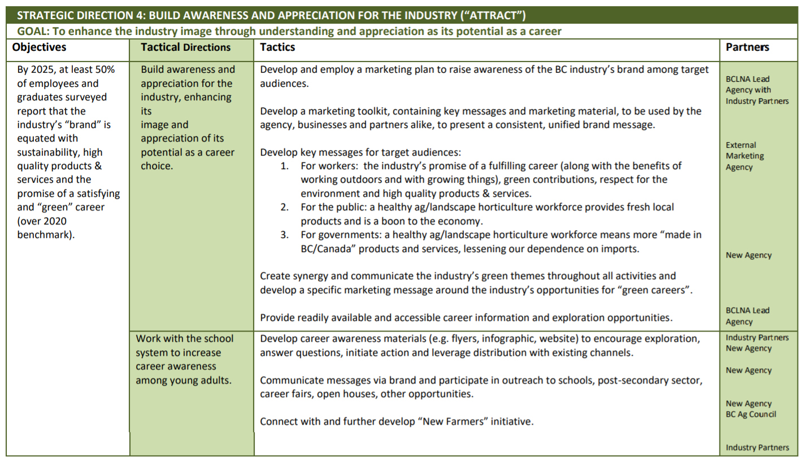

Sector Action Plan Checklist
Instructions
This checklist is a tool to help you create your sector action plan.
- Fill in each section as you complete that part of the guide.
Identify Relevant Workforce Issues
Start the development of your sector action plan by identifying what are the workforce issues affecting your sector?
Have you created a vision statement to frame the development of the sector action plan? | ☐
Have you reviewed reports and other sources of research on workforce issues and challenges your sector may be facing? (e.g., LMIs, etc.) | ☐
Have you considered information collected from sector stakeholders on challenged they may be facing? | ☐
Have you reviewed the list of workforce issues provided in the Workforce Issues and Actions Reference Table? | ☐
Identify a List of Proposed Actions
Identify proposed actions that will help to address the identified workforce issues.
Have you consulted the Workforce Issues and Actions Reference Table to identify possible proposed actions? | ☐
Have you reviewed existing sector action plans to identify possible solutions? | ☐
Have you mapped proposed actions to workforce issues? | ☐
Tailor Workforce Issues and Actions to the Sector
After you have a list of sector issues and proposed actions, you will need to tailor them to fit the needs of your specific sector. You will need to develop a more tailored and prioritized list of issues and actions and at the same time help to build sector interest and engagement.
Did you identify who is affected by the identified workforce issue? (Region, community, sector, industry, job seeker group, etc.) | ☐
Did you identify sector stakeholders that you will need to consult? | ☐
Have you identified a consultation method? | ☐
Did you identify which workforce issues are considered critical and should be treated as priorities? | ☐
Did you identify which proposed actions are considered critical and should be treated as priorities? | ☐
Create a Plan
You need to create a sector action plan that outlines how the identified proposed action can be implemented.
Have you identified how you intend to address the workforce issue and what is your desired outcome? (e.g., partners, activities, and expected results)? | ☐
Did you create SMART objectives linked to issues and proposed actions? | ☐
Have you identified how long will it take to address the identified workforce issue? (duration, anticipated start) | ☐
Did you estimate what it would cost to address the identified workforce issue (i.e., estimated project costs)? | ☐
Have you identified a way to track and measure the success of your sector action plan? | ☐
Have you identified sources of funding? | ☐

Please note that these five overarching strategic themes were developed by reviewing existing research and sector action plans in agriculture and food processing. Please note that not all these themes may be applicable to your specific sector.
Ministry of Training, Colleges and Universities. (2014). Ontario Labour Market Partnerships Guidelines.
BC Landscape & Nursery Association. (2019). British Columbia Horticulture Workforce Strategic Plan.
Food Processing Skills Canada (2020). 2020 Labour Market Information Survey: Canadian Food and Beverage Manufacturing Industry Report.
Canadian Agricultural Human Resource Council (2019). Agri-LMI- How Labour Challenges will Shape the Future of Agriculture: Agriculture Forecast to 2029.
Labour Task Force. (2015). Addressing labour shortages in the agriculture and agri-food industry through a National Workforce Action Plan.
Food and Beverage Canada (2020). A report on: Food and Beverage Canada- Labour Planning Session.
Food and Beverage Ontario (2020). A strategy for jobs and recovery on Ontario’s Food and Beverage manufacturing sector.
BC Landscape & Nursery Association (2019). British Columbia Horticulture Workforce Strategic Plan.
BC Landscape & Nursery Association. (2019). British Columbia Horticulture Workforce Strategic Plan.

